Name = Abubaker Attique

Roll num = P20-0560

Class =2A

-------------------------------------------------------------------------------------------------------------------------------------

Code

#include<iostream>

using namespace std;

int main()

{ //start of the function

cout <<"Hello World";

return 0;

}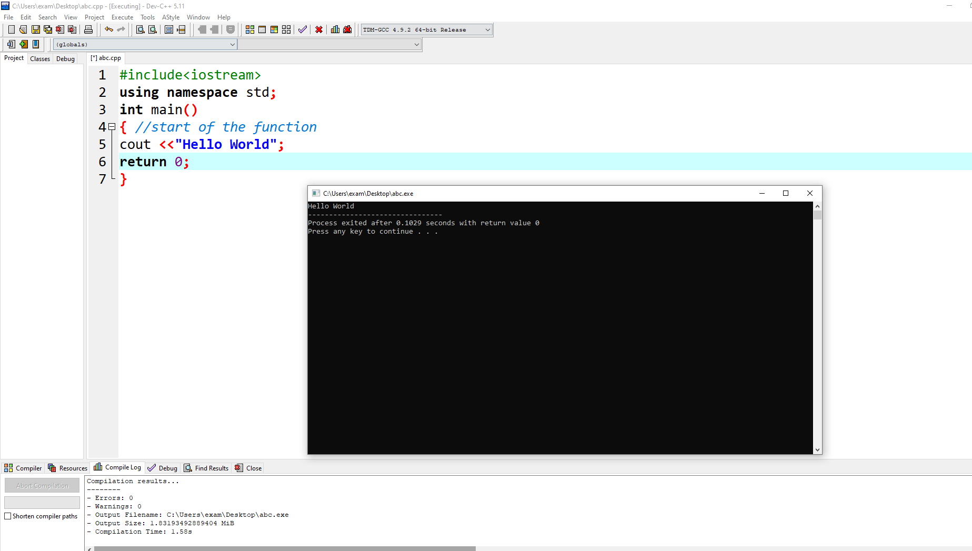

ADDING TWO NUM:

#include<iostream>

using namespace std;

int main()

{

int firstNo,secondNo,sum;

cout <<"Enter first integer\t";

cin >> firstNo;

cout <<"Enter second integer\t";

cin >> secondNo;

sum= firstNo + secondNo;

cout <<"The sum is\t:" <<sum<<endl;

return 0;

}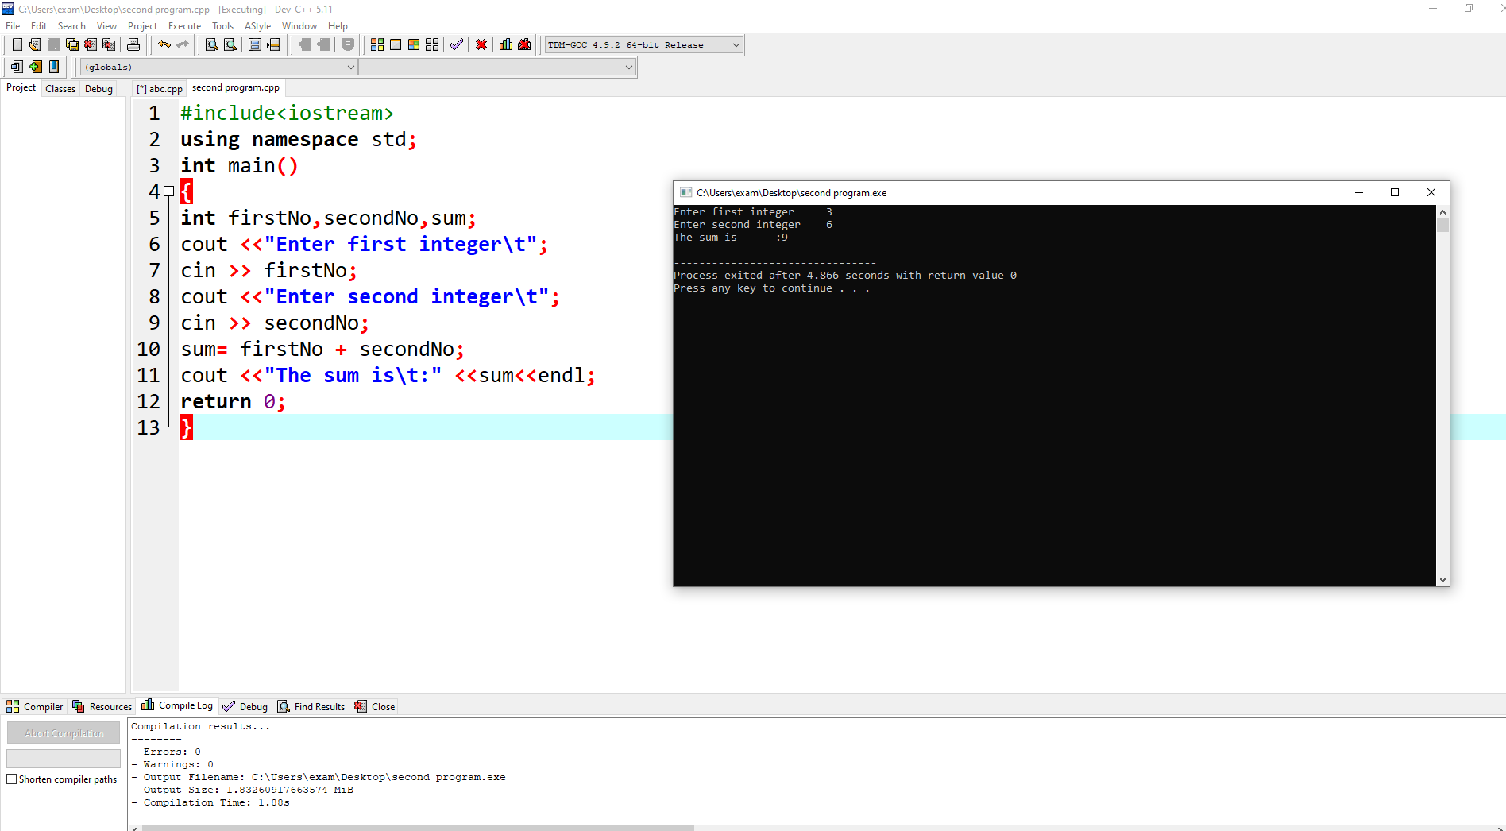

Substact

#include<iostream>

using namespace std;

int main()

{

int firstNo ,secondNo,substract;

cout <<"Enter first integer\t";

cin >> firstNo;

cout <<"Enter second integer\t";

cin >> secondNo;

substract= firstNo - secondNo;

cout <<"The answer is\t:" <<substract<<endl;

return 0;

}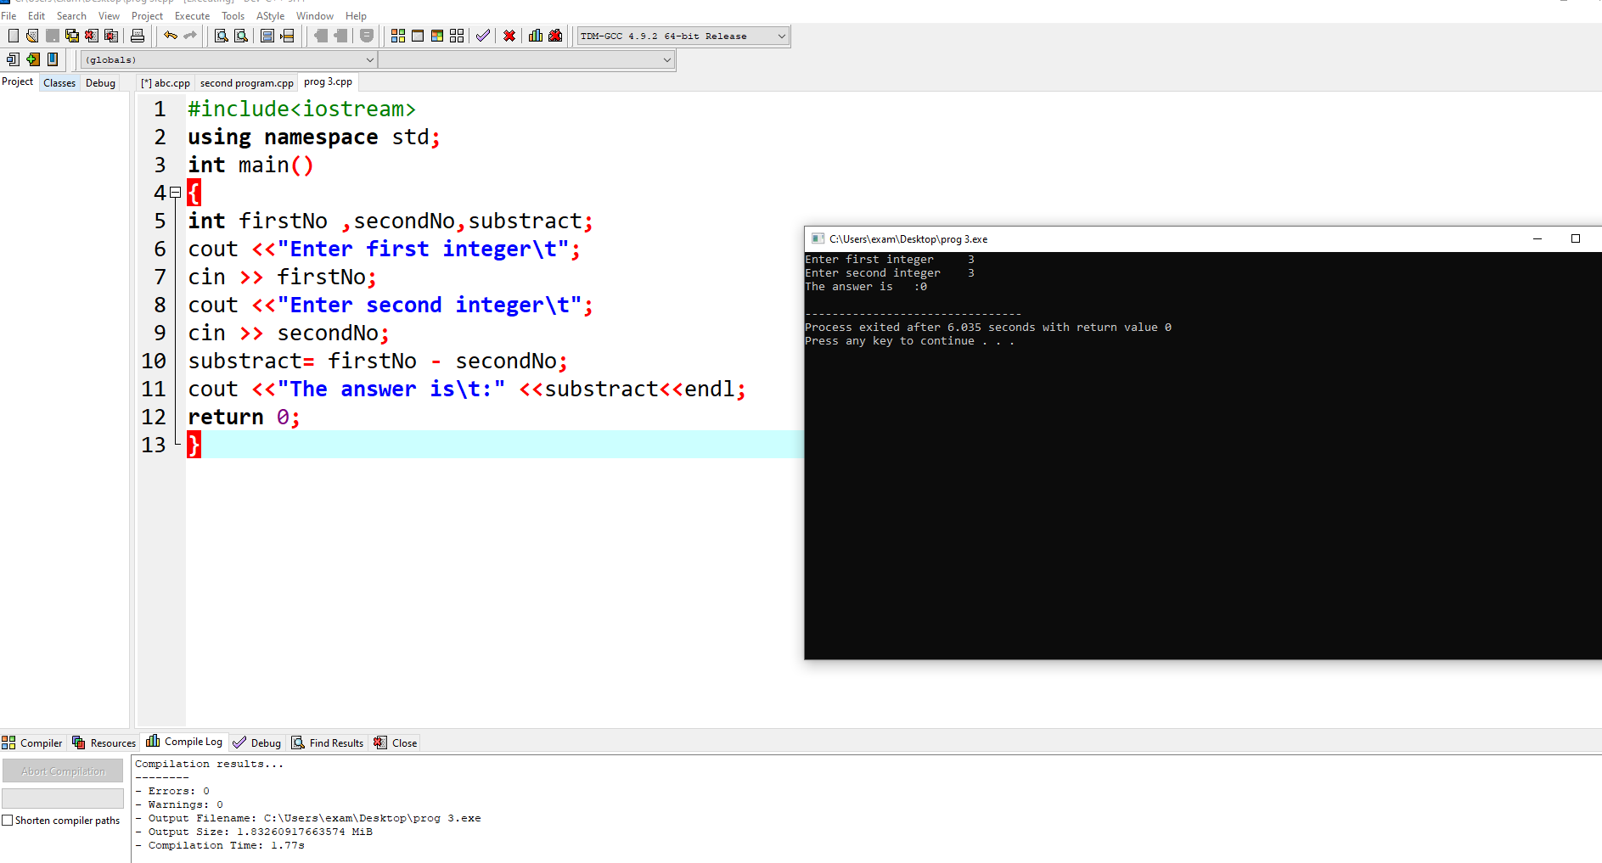

Multiply

#include<iostream>

using namespace std;

int main()

{

int firstNo,secondNo,multiply;

cout <<"Enter first integer\t";

cin >> firstNo;

cout <<"Enter second integer\t";

cin >> secondNo;

multiply= firstNo \* secondNo;

cout <<"The answer is\t:" <<multiply<<endl;

return 0;

}

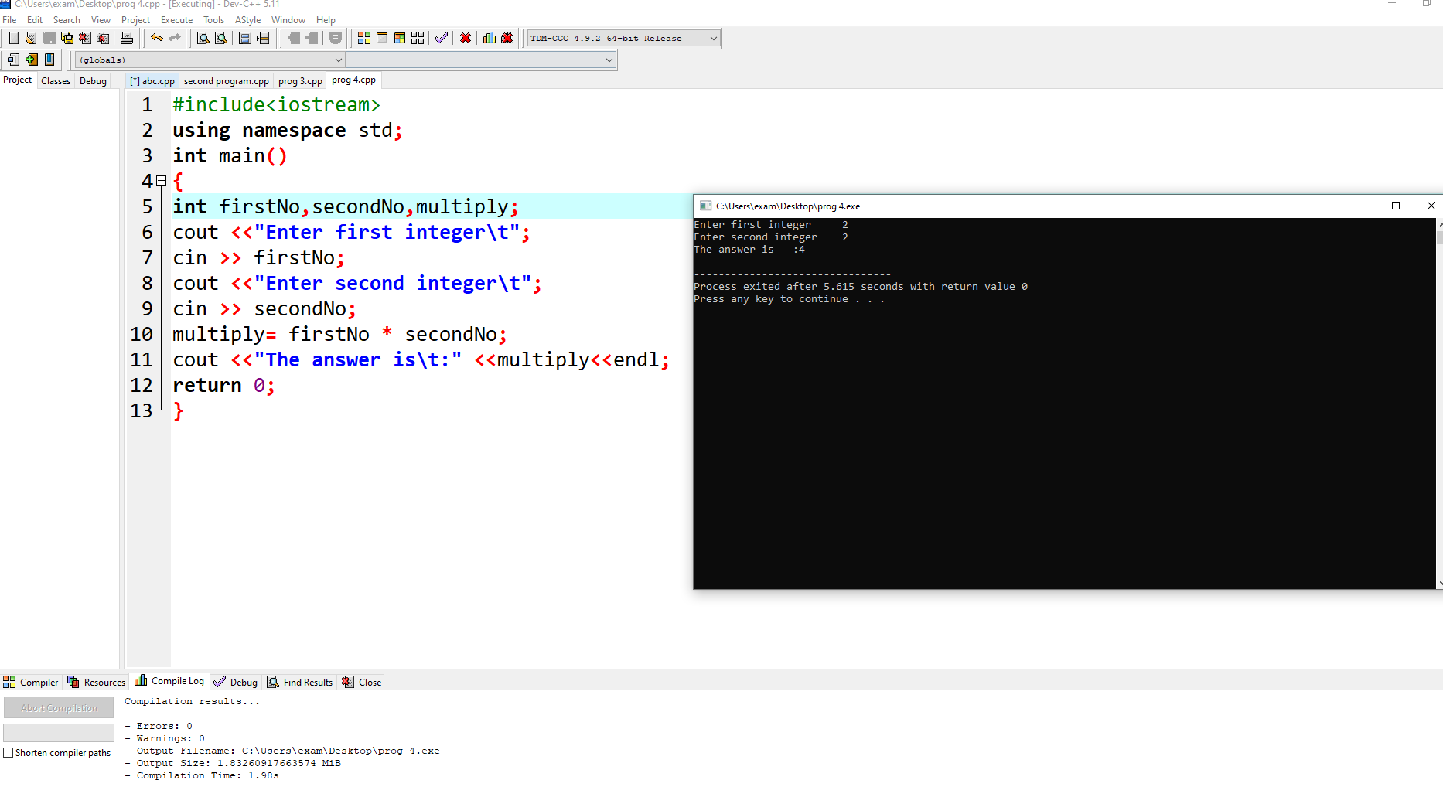

Divide

#include<iostream>

using namespace std;

int main()

{

int firstNo,secondNo,divide;

cout <<"Enter first integer\t";

cin >> firstNo;

cout <<"Enter second integer\t";

cin >> secondNo;

divide= firstNo / secondNo;

cout <<"The answer is\t:" <<divide<<endl;

return 0;

}

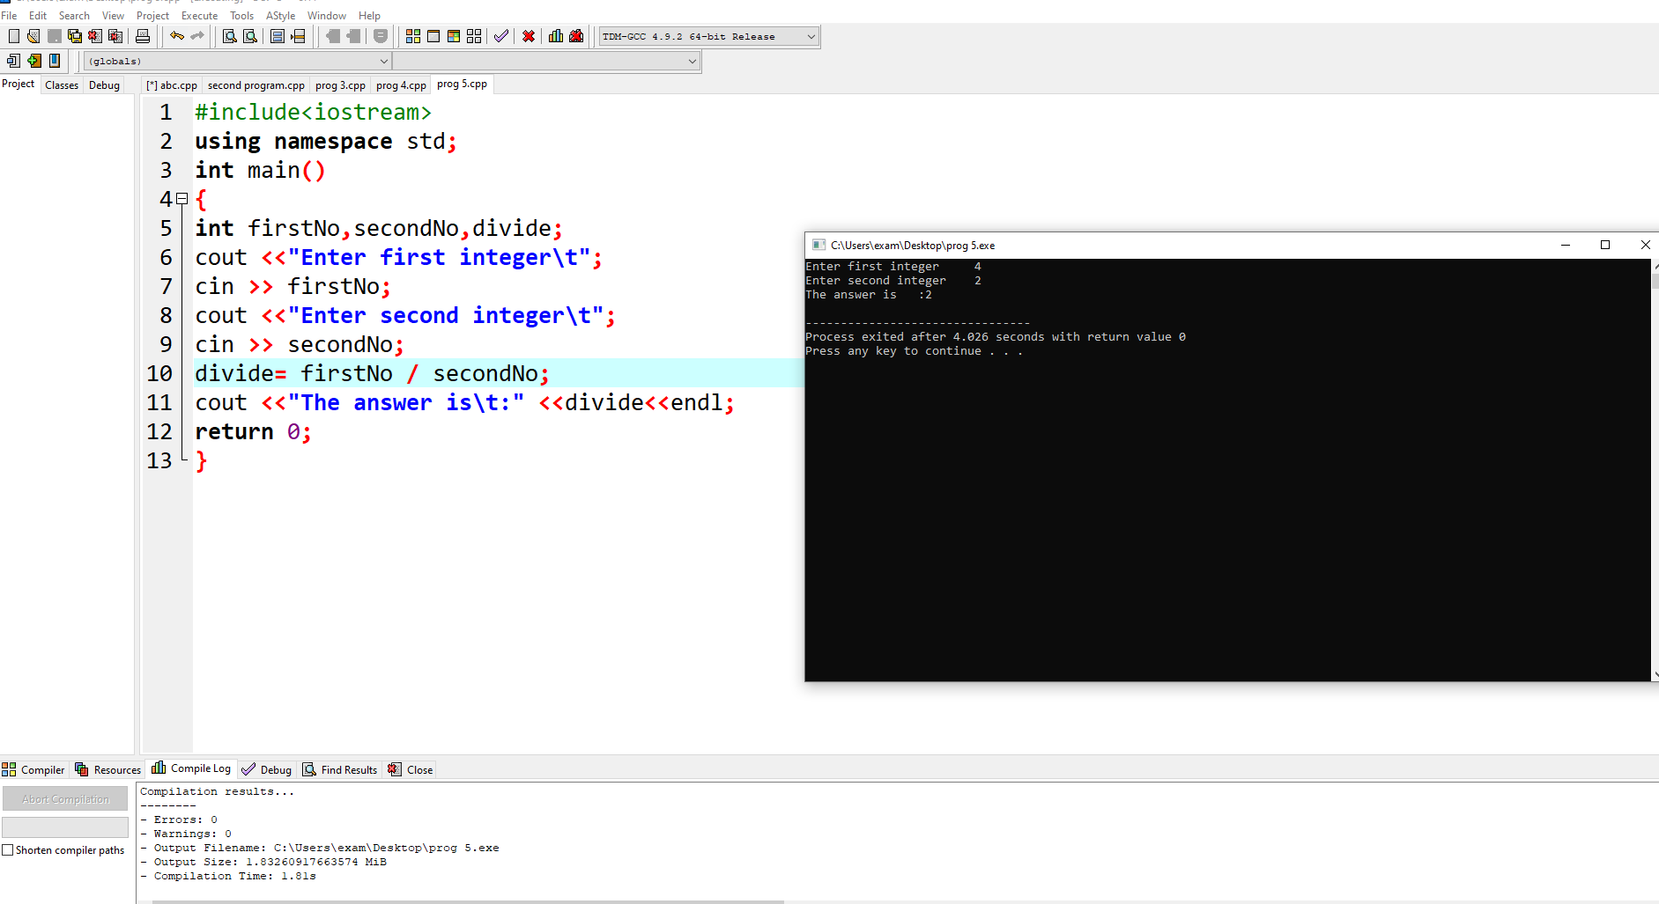

Task

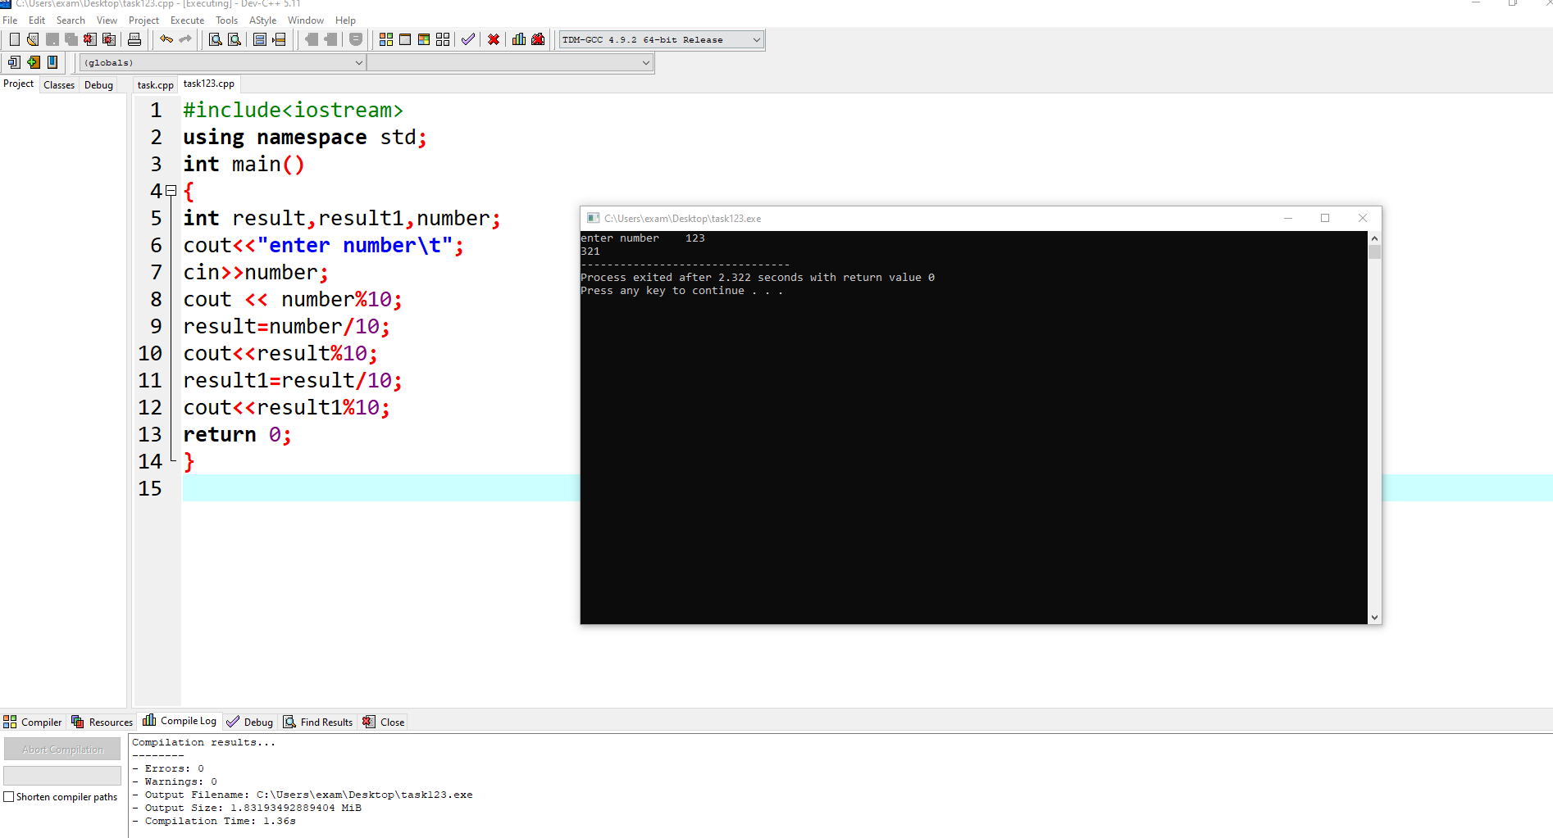

#include<iostream>

using namespace std;

int main()

{

int result,result1,number;

cout<<"enter number\t";

cin>>number;

cout << number%10;

result=number/10;

cout<<result%10;

result1=result/10;

cout<<result1%10;

return 0;

}